Program:
A program is a prepared sequence of instructions to accomplish a defined task.
The C compiler
1. Translates each source file into an object file.
2. The compiler then links the individual object files with the necessary libraries to produce an executable module.
3. When a program is run or executed, the operating system copies the executable module into a program image in main memory
Multistage Processing of a User Program
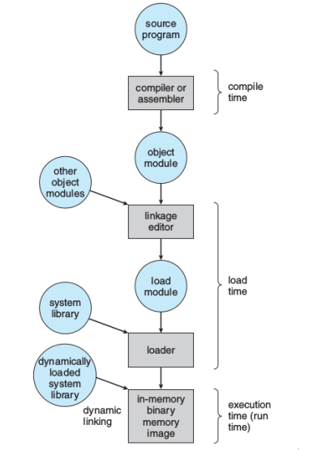

Layout of a Program Image in Main Memory
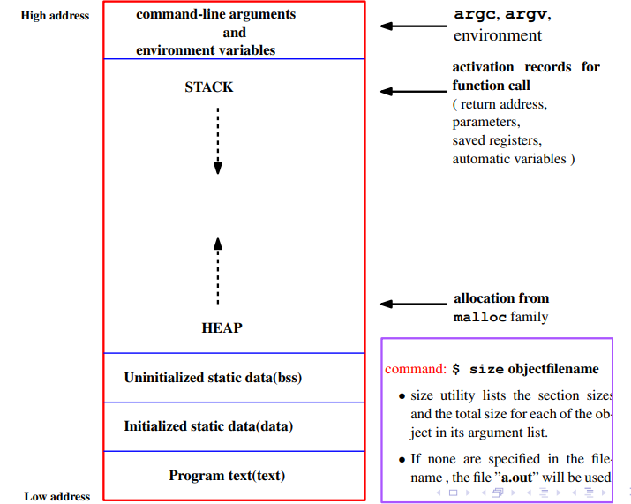
Process
process is an instance of a program that is executing (A program which is dispatched from ready state and are scheduled for execution)
When does program become process?
☞The operating system reads the program into memory.
☞ The allocation of memory for the program image is not enough to make the program a process.
☞ The process must have an ID (the process ID) so that the operating system can distinguish among individual processes. The process state indicates the execution status of an individual process.
☞ The operating system keeps track of the process IDs and corresponding process states and uses the information to allocate and manage resources for the system.
☞ The operating system also manages the memory occupied by the processes and the memory available for allocation.
☞ When the operating system has added the appropriate information in the kernel data structures and has allocated the necessary resources to run the program code, the program has become a process.
☞ A process has an address space (memory it can access) and at least one flow of control called a thread.
☞ The variables of a process can either remain in existence for the life of the process (static storage) or be automatically allocated when execution enters a block and deallocated when execution leaves the block (automatic storage)
Process State
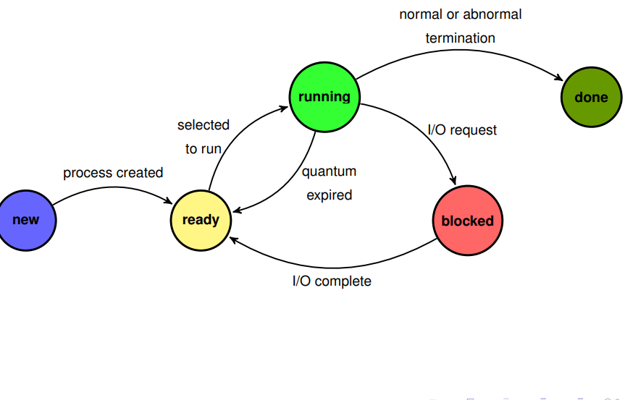
Thread :
A thread is a single sequence stream within a process. Threads are also called lightweight processes as they possess some of the properties of processes. A thread is a lightweight subpart of that process that performs a specific task.
Example:
Operating System
│
└── Chrome Main Process (chrome.exe)
├── Renderer Process (for Tab 1)
│ ├── Main/UI Thread
│ ├── Compositor Thread
│ └── IO Thread
│
├── Renderer Process (for Tab 2)
│ ├── Main/UI Thread
│ ├── Compositor Thread
│ └── IO Thread
│
├── GPU Process
│ └── Rendering Threads
│
├── Network Process
│ └── Download and Socket Threads
│
└── Extension Process
└── Background Script Threads

Tracking ongoing processes
1. ps (Process status) can be used to see/list all the running processes.
For single-process information, ps along with process id is used
-a: Shows information about all users
-x: Shows information about processes without terminals
-u: Shows additional information
-f: Displays full information For a running program
ps -al : Shows information about all process
ps -ef: Full-format listing
ps aux: BSD-style detailed view

Outputs
Pidof finds the process id’s (pid Fields described by ps are described as:
● UID: User ID that this process belongs to (the person running it)
● PID: Process ID
● PPID: Parent process ID (the ID of the process that started it)
● C: CPU utilization of process
● STIME: Process start time
● TTY: Terminal type associated with the process
● TIME: CPU time is taken by the process
● CMD: The command that started this process
● VSZ: Total amount of virtual memory used by the process
● RSS: Actual physical memory (RAM) currently occupied by the process (in kilobytes). This excludes memory swapped out to disk.

2. Kill: Used to stop a process
Syntax:: $ kill process-id Example:: $ kill 4578
Process Identification
☞UNIX identifies processes by a unique integral value called the process ID.
☞ Each process also has a parent process ID, which is initially the process ID of the process that created it.
☞ If this parent process terminates, the process is adopted by a system process so that the parent process ID always identifies a valid process.
getpid and getppid Function
The getpid function returns the process ID .
☞ The getppid function returns the parent process ID.
☞ The pid_t is an unsigned integer type that represents a process ID.
#include <unistd.h>
pid_t getpid(void);
pid_t getppid(void);
Neither the getpid nor the getppid functions can return an
error.

Example
#include<stdio.h>
#include<unistd.h>
int main (void)
{
printf("I am process %ld\n", (long)getpid());
printf("My parent is %ld\n", (long)getppid());
return 0;
}

UNIX Process Creation and fork
✍ A process can create a new process by calling fork.
✍ The calling process becomes the parent, and the created process is
called the child.
✍ The fork function copies the parent’s memory image so that the new
process receives a copy of the address space of the parent.
✍ Both processes continue at the instruction after the fork statement (executing in their respective memory images).
✍ fork() prototype
#include <unistd.h>
pid_t fork(void);

✍ fork() function returns
(1) returns 0 to the child
(2) returns the child’s process ID to the parent.
(3) When fork fails, it returns -1
Note:: The fork function return value is the critical characteristic that allows the parent and the child to distinguish themselves and to execute different code.
Example:
#include <stdio.h>
#include <unistd.h>

int main() {
pid_t pid = fork();

if (pid > 0)
printf("Parent Process: PID = %d, Child PID = %d\n", getpid(), pid);
else if (pid == 0)
printf("Child Process: PID = %d, Parent PID = %d\n", getpid(), getppid());
else
printf("Fork failed!\n");
return 0;
}
Example 1:
#include <stdio.h>
#include <unistd.h>
int main() {
printf("Before fork\n");
fork();
printf("After fork\n");
return 0;
}
o/p: Before fork
After fork
After fork
Explanation
P #before fork
(fork)

C P #After fork

Or
Parent process
#include <stdio.h>
#include <unistd.h>
int main() {
printf("Before fork\n");
fork();
printf("After fork\n");
return 0;
}

Child process
#include <stdio.h>
#include <unistd.h>
int main() {
printf("After fork\n");
return 0;
}

Example2:
#include <stdio.h>
#include <unistd.h>
int main() {
fork(); // 1st fork
fork(); // 2nd fork
printf("Process: PID = %d, PPID = %d\n", getpid(), getppid());
return 0;
}
Explanation:
Parent
Child 0
#include <stdio.h>
#include <unistd.h>
int main() {
fork(); // 1st fork
fork(); // 2nd fork
printf("Process: PID = %d, PPID = %d\n", getpid(), getppid());
return 0;
}

Child 2
#include <stdio.h>
#include <unistd.h>
int main() {
printf("Process: PID = %d, PPID = %d\n", getpid(), getppid());
return 0;
}

#include <stdio.h>
#include <unistd.h>
int main() {
fork(); // 2nd fork
printf("Process: PID = %d, PPID = %d\n", getpid(), getppid());
return 0;
}

Child 1
#include <stdio.h>
#include <unistd.h>
int main() {
printf("Process: PID = %d, PPID = %d\n", getpid(), getppid());
return 0;
}

Process Tree Visualization
Parent (P0)
├── Child1 (P1)
│ └── Grandchild (P3)
└── Child2 (P2)
or

P
C1 P
C2 C1 C3 P

Remember: Total = 2ⁿ processes (for n successful forks).
Example:
#include <stdio.h>
#include <unistd.h>
int main() {
fork();
if (fork())
fork();
printf("PID=%d\n", getpid());
return 0;
}

printf("PID=%d\n", getpid());
return 0;
}

if (fork())
fork();
printf("PID=%d\n", getpid());
return 0;
}

printf()
return 0;
}

if (1)
fork();
printf()
return 0;
}

#include <stdio.h>
#include <unistd.h>
int main() {
fork();
if (fork())
fork();
printf("PID=%d\n", getpid());
return 0;
}

printf()
return 0;
}

if (1)
fork();
printf("PID=%d\n", getpid());
return 0;
}

printf("PID=%d\n", getpid());
return 0;
}

printf("PID=%d\n", getpid());
return 0;
}

printf("PID=%d\n", getpid());
return 0;
}

Example:
#include <stdio.h>
#include <unistd.h>
int main() {
for (int i = 0; i < 3; i++)
fork();
printf("Hi");
return 0;
}

